**Assignment VII:**

**Partials and Customer Users**

#### Note: You need a server up and running, below is a nice set up of a server file.

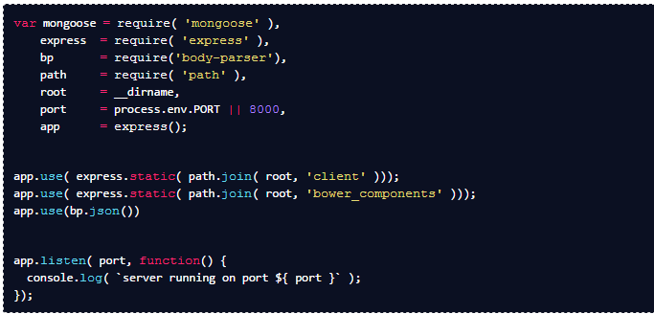

var mongoose = require( 'mongoose' ),

express = require( 'express' ),

bp = require('body-parser'),

path = require( 'path' ),

root = __dirname,

port = process.env.PORT || 8000,

app = express();

app.use( express.static( path.join( root, 'client' )));

app.use( express.static( path.join( root, 'bower_components' )));

app.use(bp.json())

app.listen( port, function() {

console.log( `server running on port ${ port }` );

});

#### In the server above: Why don’t we need to have a route listening for (’/’) and rendering index.html (and where should the index.html file be located)?

* Create an angular - app with 2 partial pages.

1. customizeUsers.html
   * create user
   * delete user
2. userList.html
   * show all users

* Each partial page will have its own controller.

1. CustomizeUsersController (notice plural, capitalized naming on the controller name)
2. UserListsController

* Both controllers will inject the userFactory.

1. userFactory Methods
   * index: Retrieve all users
   * create: add users
   * delete: destroy one user
   * show: show one user (not activated)
   1. userFactory Property (you can make these private)
   * users: array of users objects

